Lab Exercise 8

Configuring Multibranch Jenkins Pipeline Job

Step 1: Create a Git repository

1.1 Open the browser in your lab, go to github.com, and sign in to your account

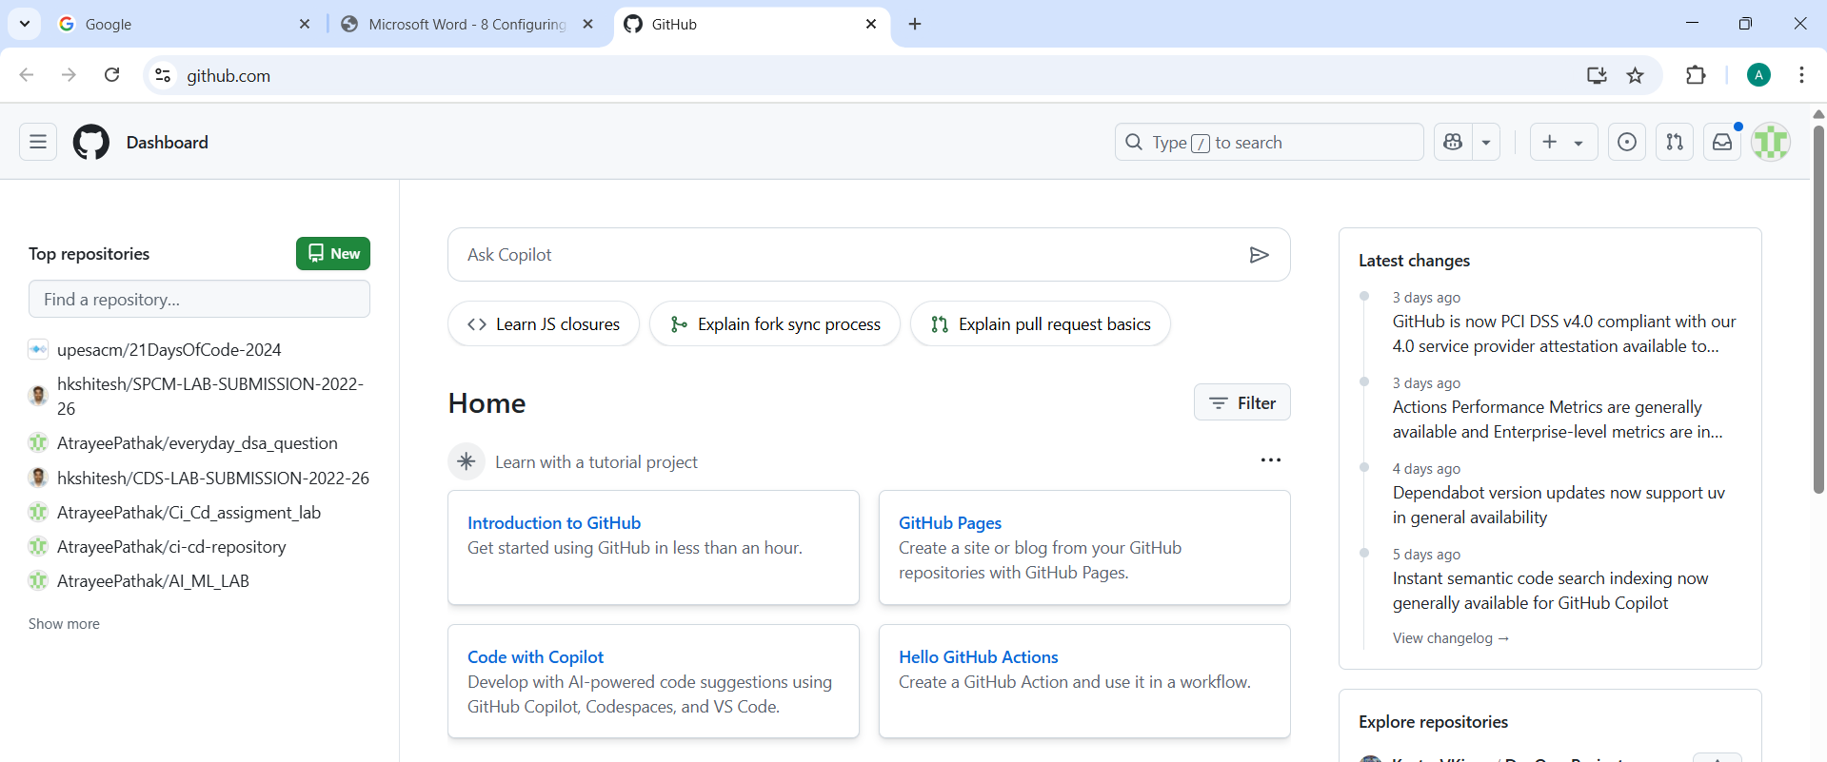

1.2 Click on New as shown in the screenshot below:

1.3 Enter a desired name for your repository and choose Public as shown in the screenshot below:

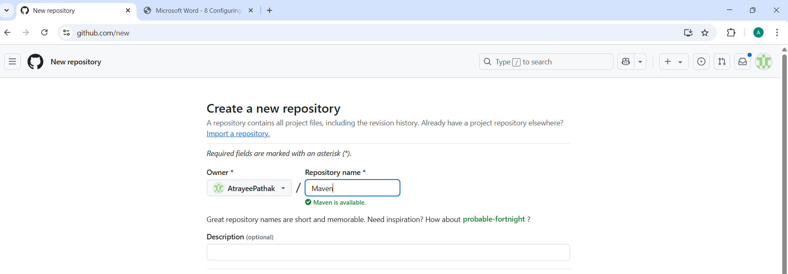

1.4 Click on Add a README file and then click on Create repository as shown in the screenshot below:

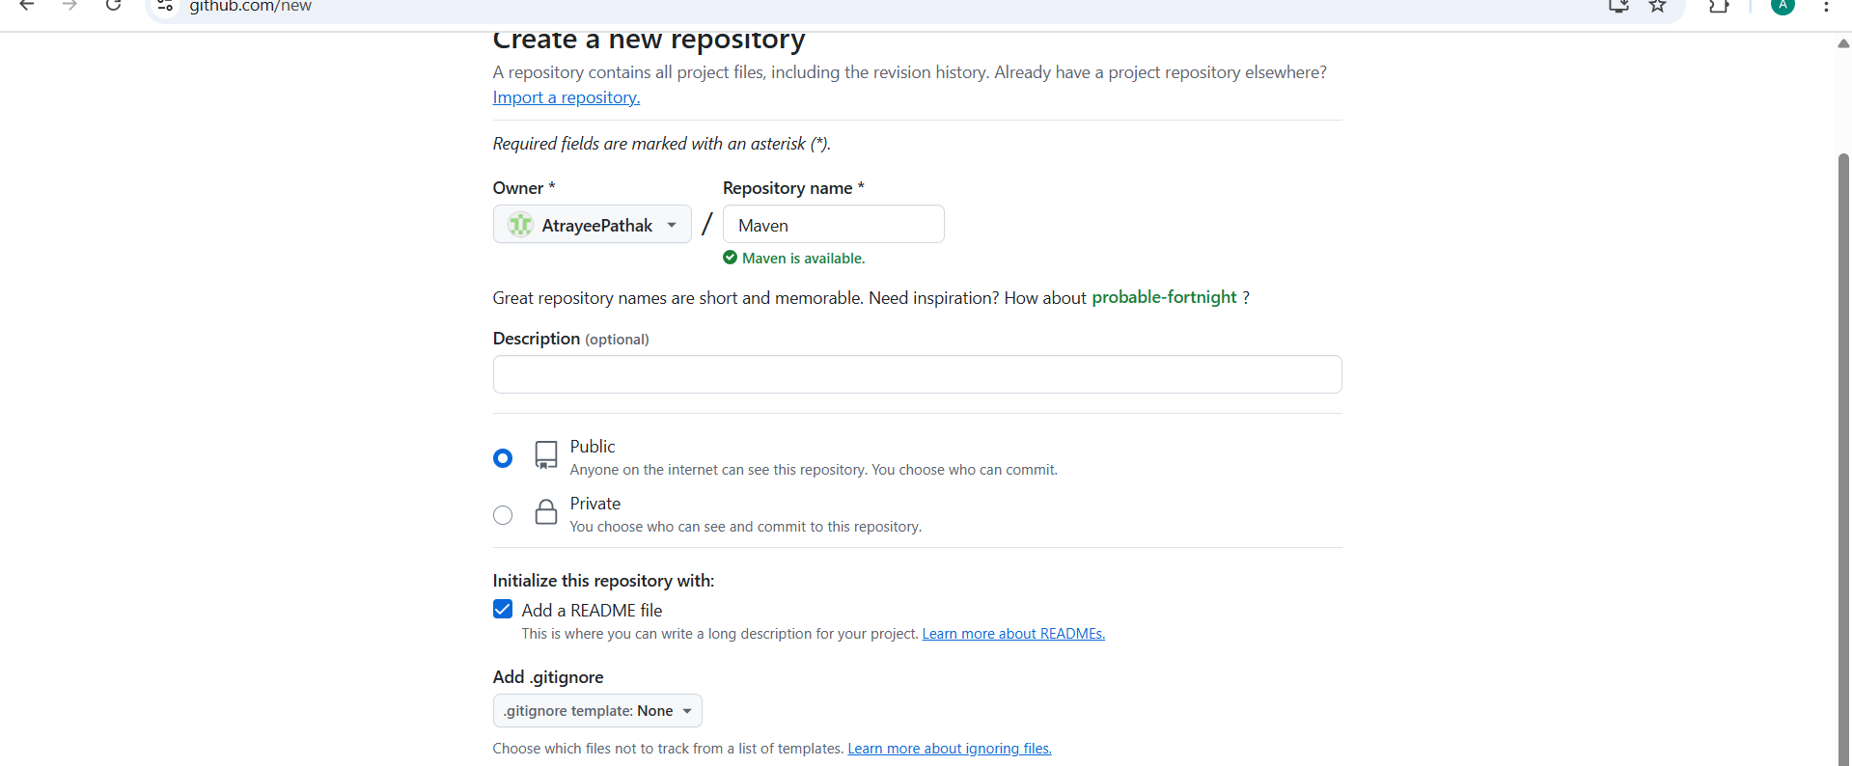

1.5 Click on Code as shown in the screenshot below:

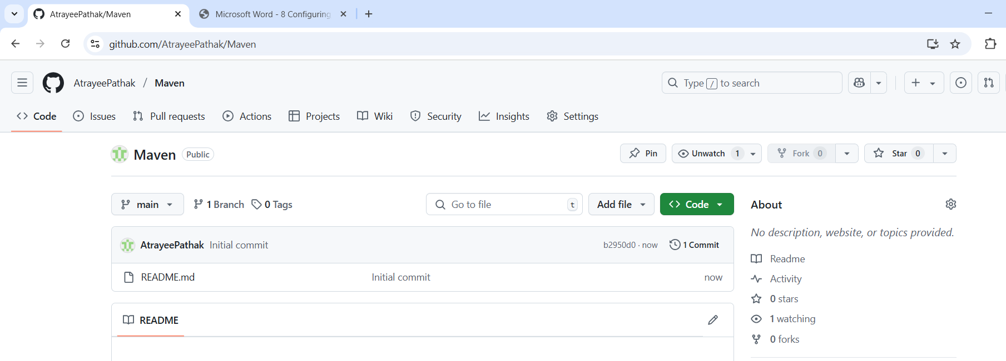

1.6 Copy the repository URL

<https://github.com/AtrayeePathak/Maven.git>

Step 2: Push the code file into the Git repository

2.1 Open the Linux terminal in your lab and clone the repository using the below command: git clone RepositoryURL

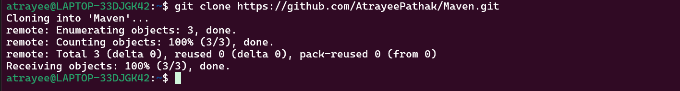

2.2 Navigate inside the repository that you had created using the below command: cd RepositoryName

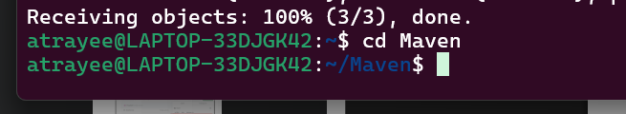

2.3 Initialize the Git using the below command: git init



2.4 Create a file using the below command: nano demofile

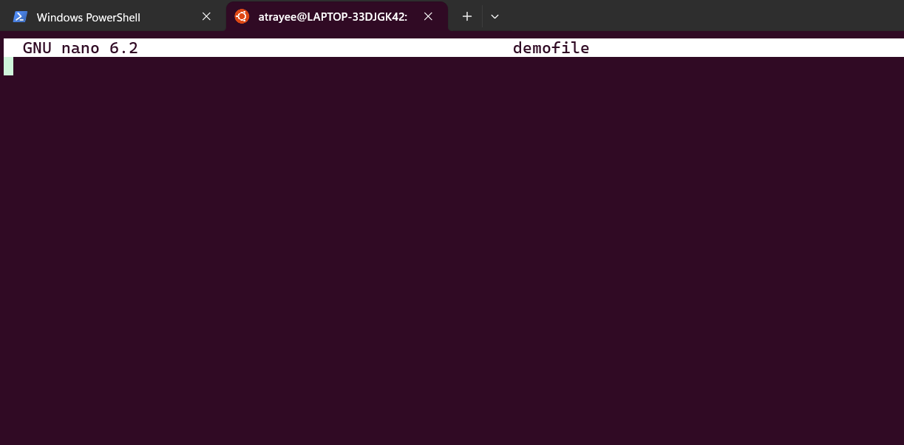

2.5 Paste the below pipeline script inside the file as shown in the screenshot below:

pipeline {

agent any

stages {

stage('Checkout') {

steps {

// Checkout your source code from version control

git 'https://github.com/your/repository.git'

}

}

stage('Build') {

steps {

// Use Maven to build your project

sh 'mvn clean package'

}

}

stage('Test') {

steps {

// Run tests if applicable

sh 'mvn test'

}

}

stage('Deploy') {

steps {

// Deploy your artifact, if necessary

// Example: sh 'mvn deploy'

}

}

}

post {

success {

// This block will be executed if the pipeline runs successfully

echo 'Pipeline executed successfully!'

}

failure {

// This block will be executed if the pipeline fails

echo 'Pipeline failed!'

}

}

}

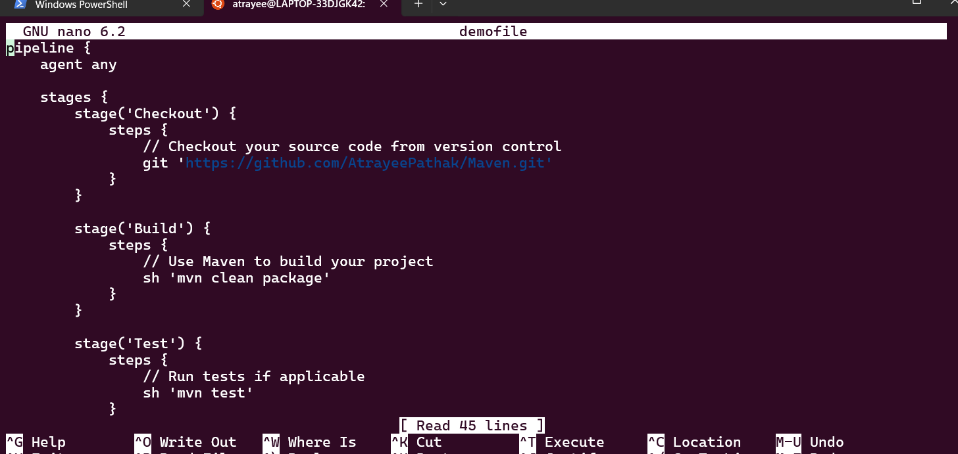

2.6 Stage and commit the changes using the below commands: git add . git commit -m “initial commit”

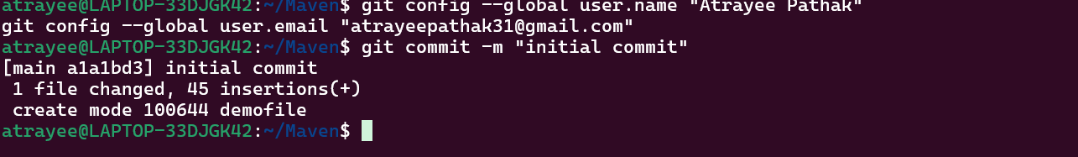

2.7 Push the file to the Git repository using the below command: git push

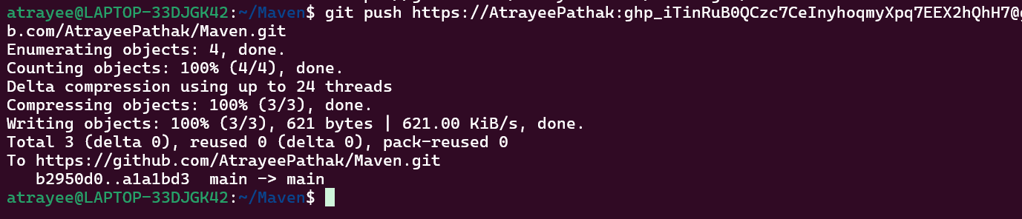

2.8 Navigate to your Git repository to check for the file that is pushed:

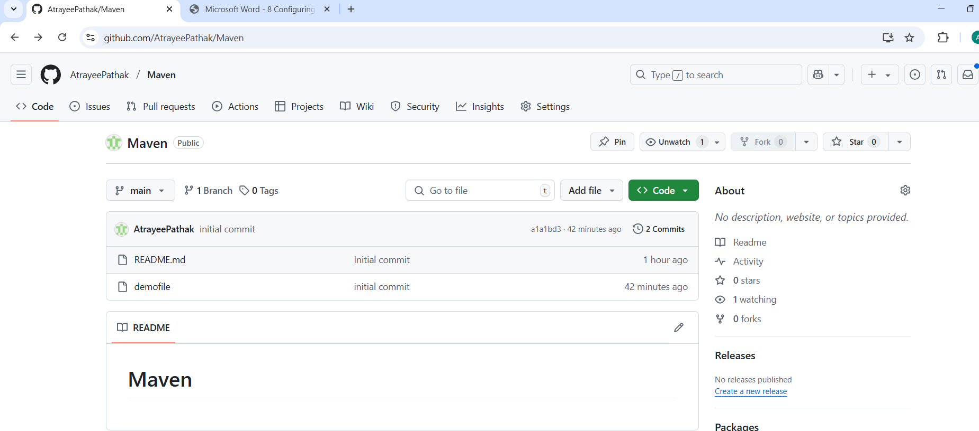

Step 3: Create a Multibranch Pipeline

3.1 Open the browser, go to the Jenkins Dashboard by typing localhost:8080 in your browser,

provide the credentials, and click the Sign in button

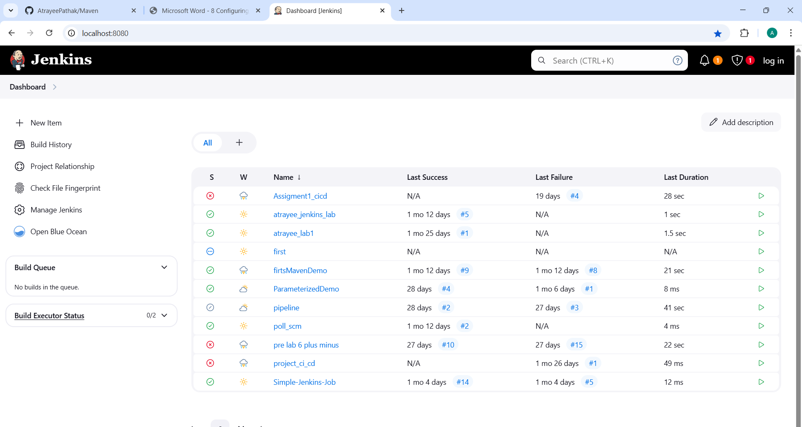

3.3 Enter a desired name for the project as shown in the screenshot below:

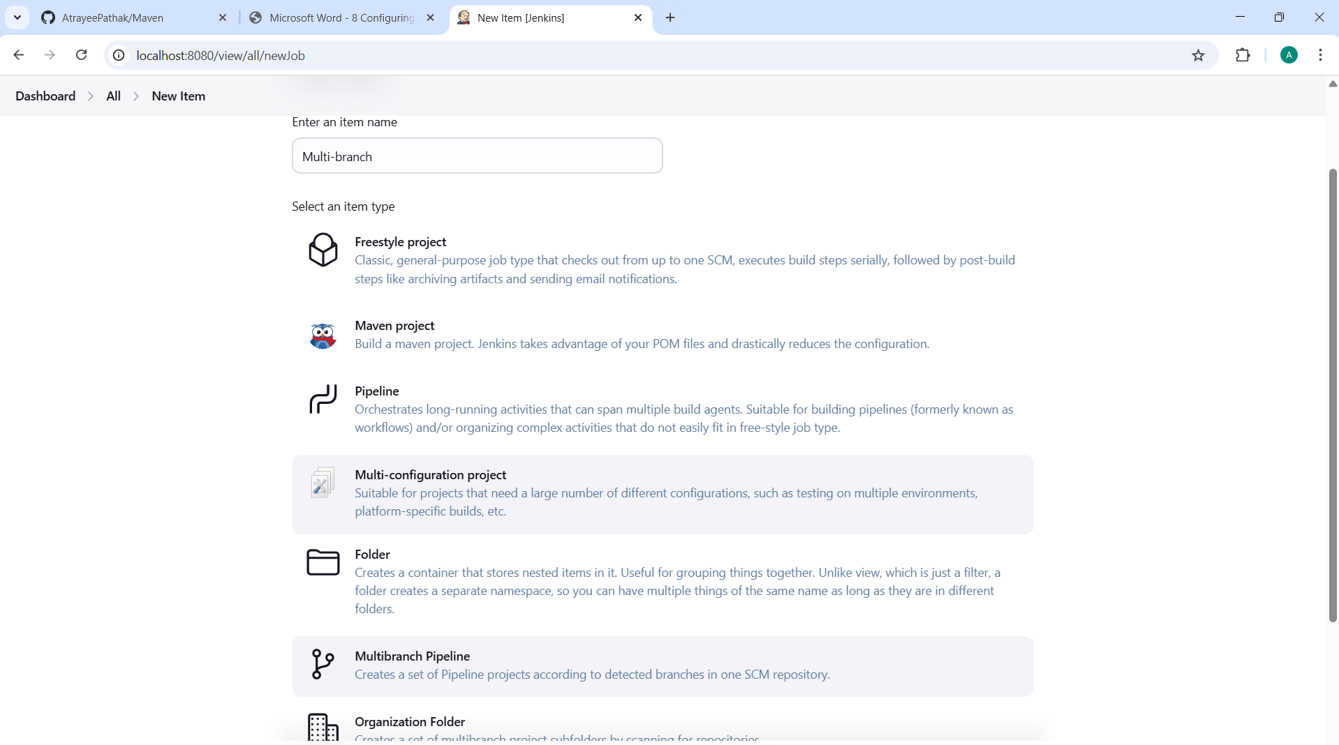

3.10 Click on Scan Repository Log as shown in the screenshot below:

